**MARCH 2020 LAURIE CARE NEWS & VIEWS VOLUME 3 ISSUE 1**

**Laurie Care Center/Laurie Knolls  P O Box 1068  Laurie MO 65038**

**573.374.8263  573.374.0603 (Fax)  www.gsnhd.com**

**DISTRICT ADMINISTRATOR**

Lance Smith

[lsmith@gsnhd1.com](mailto:lsmith@gsnhd1.com)

**ADMINISTRATOR**

Katherine Carlson

[kcarlson@gsnhd1.com](mailto:kcarlson@gsnhd1.com)

**DIRECTOR OF NURSING**

**Cora Huber**

**chuber@gsnhd1.com**

**MARKETING/ADMISSIONS**

Director, Jennie Fisher

[**jfisher@gsnhd1.com**](mailto:jfisher@gsnhd1.com)

**DISTRICT C.F.O.**

Lana Marriott

[lmarriott@gsnhd1.com](mailto:lmarriott@gsnhd1.com)

**ACTIVITY DIRECTOR**

Brenda Thornton

[bthornton@gsnhd1.com](mailto:bthornton@gsnhd1.com)

**DIETARY MANAGER**

Jim Neff

[jneff@gsnhd1.com](mailto:jneff@gsnhd1.com)

**HUMAN RESOURCES**

Theresa Moyer

[tmoyer@gsnhd1.com](mailto:tmoyer@gsnhd1.com)

**VOLUNTEER COORDINATOR**

Saundra Chorpening

573-207-8806

[sl.chorpening@gmail.com](mailto:sl.chorpening@gmail.com)

**Happy Easter!!!**

Well, Spring is here, despite what is happening in the world today! Times are challenging to say the least. We are trying our best to keep spirits up and have a fun. Not being able to see our loved ones in person and get those all- important hugs is a little hard on everyone! We are offering face time to our residents and their families. if anyone is interested call Brenda in activities and we can get things set up. Here’s hoping this virus gets out of here in a hurry. SO OVER the Corona Virus and it’s havoc!!

Meanwhile, we have been doing activities, just in a different way. Lots of hallway bingo! We have been doing most of our activities together in our doorways in the hall. Keep that social distancing up! A Little hallway hockey keeps us busy too. Of course, we keep our strength up with sit-nb-fit too! We have car races and an Easter Egg Scavenger Hunt coming up too! We will be cooking out some hotdogs and enjoying the outdoors in the days to come. I’m always open to any ideas for fun activities

Brenda Thornton

Activities Director

VOLUNTEER CORNER

THANK YOU FOR YOUR HARD WORK AND DEDICATION EVEN THROUGH THESE HARD TIMES. THE MASKS THAT YOU ALL HAVE WORKED SO HARD ON ARE APPRECIATED MORE THAN YOU COULD EVER IMAGINE. WHEN TIMES GET TOUGH…OUR VOLUNTEERS COME TROUGH!!! WE LOVE YOU ALL AND CAN’T WAIT FOR THE DAY TO COME WHEN THINGS GO BACK TO NORMAL. WILL BE SO GLAD TO SEE YOUR FACES AGAIN!

THE STAFF OF LAURIE CARE CENTER & THE KNOLLS

***NO CHURCH SERVICES DUE TO THE CORONA VIRUS LOCKDOWN***

***We miss you all!!!!***

***SUNDAY CHURCH SERVICES-2:00 PM TUESDAY CHURCH***

**7th Mass @ 10:00 am**

**5th 14 th Rosary/Mass @ 9:30 am**

**12th 17th Mass @ 10:00 am**

**19th 21st Mass @ 10:00 am**

**26th 28th Mass @ 10:00 am**

**Thank you, Brother Brent for our Memorial Moments Service the first Tuesday of each month. We really appreciate it.**

**We appreciate those coming on Sundays and St. Patrick Catholic Church on Tuesday’s. Your efforts in providing religious services are a blessing to our residents. Thank you.**

***BINGO SCHEDULE***

**Those helping on Tuesdays at 2:00 pm Bonnie Ferment – Wednesday @ 10:00**

**7th LCC Marsha Lenne – Saturday @ 10:00**

**14th LCC**

**21st LCC NO BINGO DUE TO THE CORONA VIRUS LOCKDOWN**

**28th LCC**



**APRIL 2 LUIS MARTINEZ**

**APRIL 4 MILDRED WYRWICKI**

**APRIL 17 IRMA TREGO**

**APRIL 19 PATRICIA BERRYHILL**

**APRIL 19 DONNA PERRY-KISSEL**

**APRIL 20 MARIETTA ARNOLD**

HALLWAY

HOCKEY



[This Photo](http://tatumalmablog.blogspot.com/2014/01/hockey-sticks-pics.html) by Unknown Author is licensed under [CC BY](https://creativecommons.org/licenses/by/3.0/)

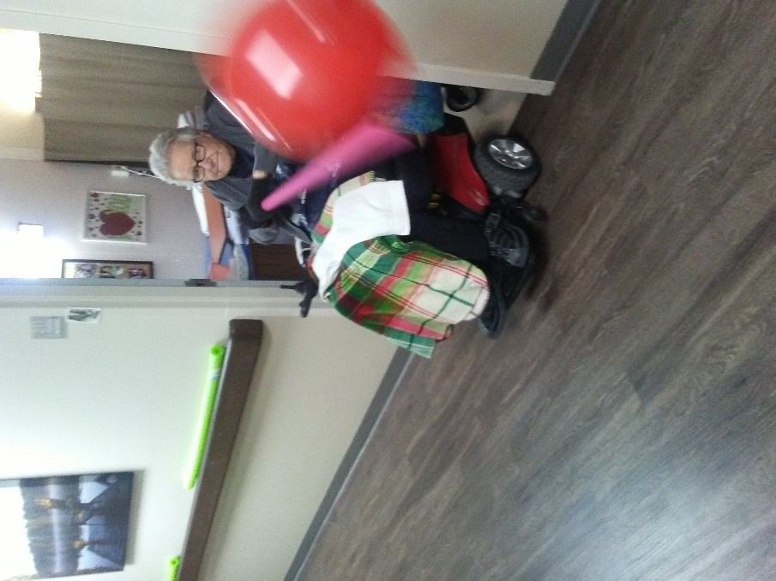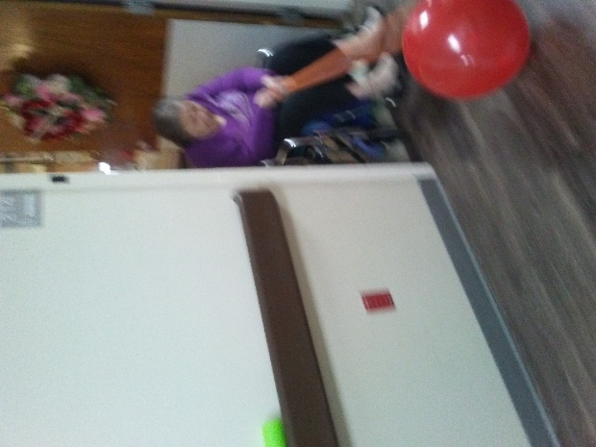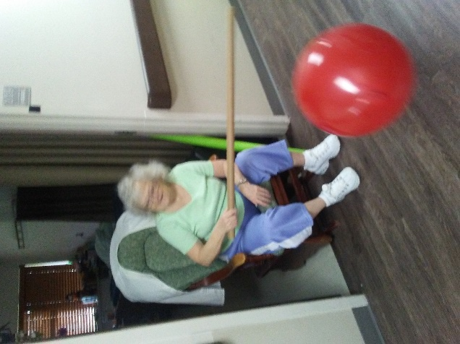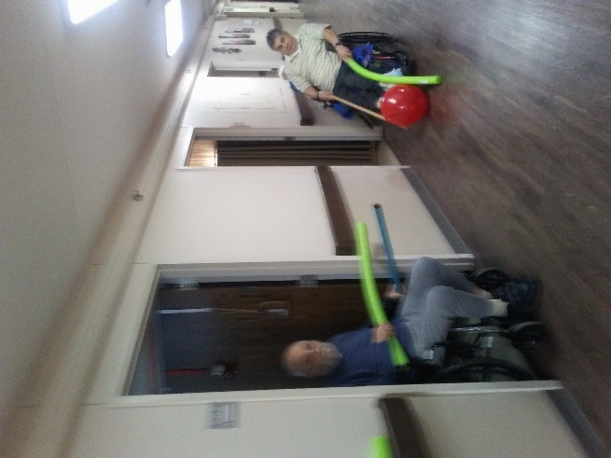

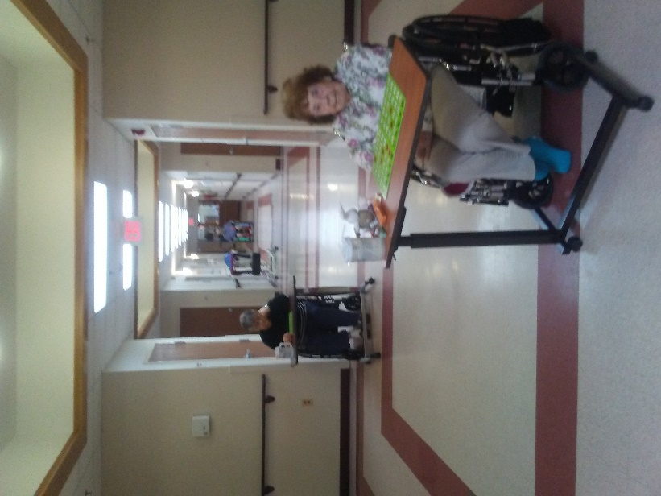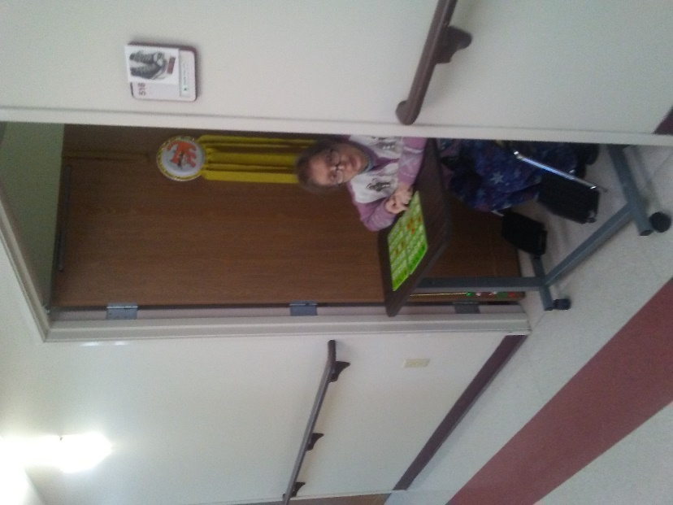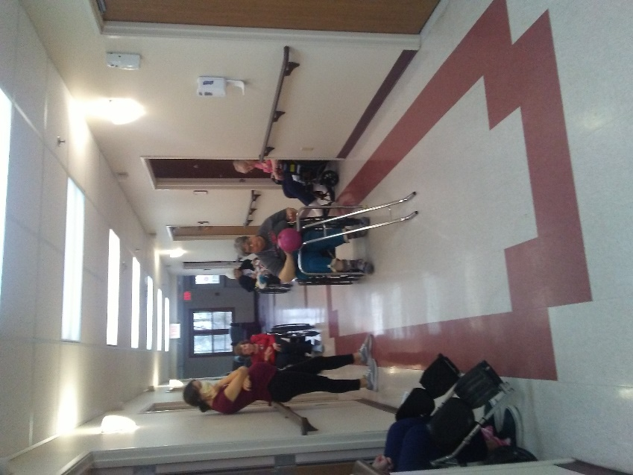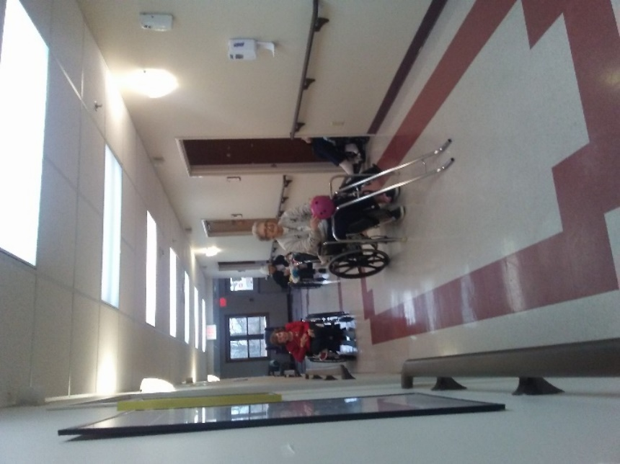 **BOWLING!**

**B**

**I**

**N**

**G**

**O**



[This Photo](http://pngimg.com/download/24367) by Unknown Author is licensed under [CC BY-NC](https://creativecommons.org/licenses/by-nc/3.0/)

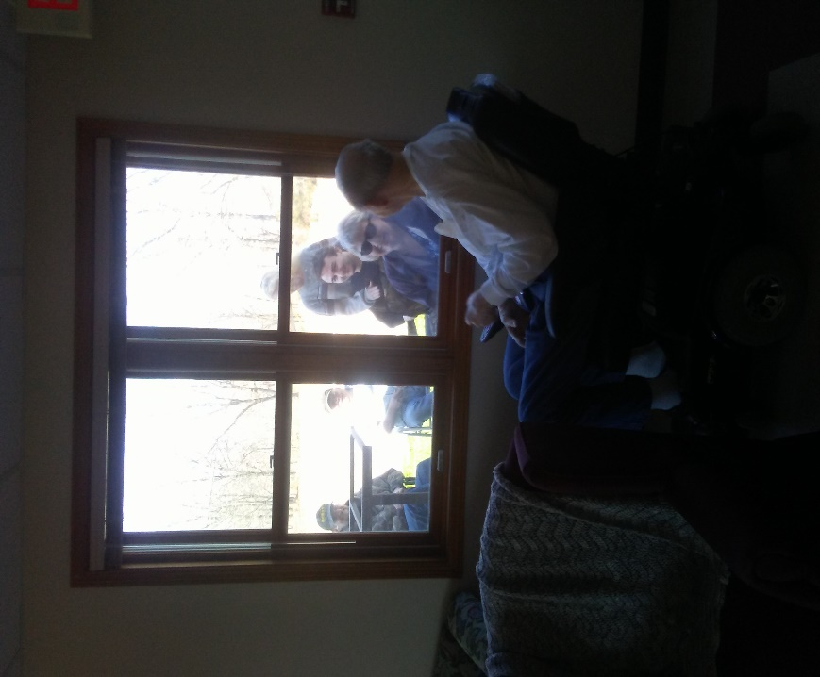

LOVE & **FAMILY**