Sunday | Monday | Tuesday | Wednesday | Thursday | Friday | Saturday
1 | 2 | 3 | 4 | 5 | 6 | 7
8  Daylight Saving Time Begins | 9  Purim Begins | 10 | 11 | 12 | 13 | 14
15 | 16 | 17  St. Patrick’s Day | 18 | 19  Spring Begins | 20 | 21
22 | 23 | 24 | 25 | 26 | 27 | 28
29 | 30 | 31

2:00 CHURCH SERVICE  CROSSROADS  ASSEMBLY OF  GOD | 9:00 SIT NB FIT  9:30 BIBLE STUDY  W/CHUCK  11:00 SPICE KITCHEN  1:00 TIC TAC TOE  2:00 MINI GOLF  3:00 GOLF TRIVIA | 9:00 FALL  PREVENTION CLASS  10:00 MASS  11:00 MEMORIAL  MOMENTS  1:00 RAINBOW CHAIN  2:00 BINGO  3:00 BALLOON TOSS | 9:00 SIT NB FIT  10:00 BINGO W/BONNIE  11:00 1TO 1’S  1:00 RAINBOW CHAIN  2:00 BOWLING  W/LADY ELKS  3:00 ICE CREAM | 9:00 SIT NB FIT  10:00 PRETTY NAILS  11:00 SHAPE MATCH  1:00 RAINBOW CHAIN  2:00 JEOPARDY  3:00 B-DAY PARTY HAPPY B-DAY DAWN PHILLIPS | 9:00 SIT NB FIT  9:30 RESIDENT  COUNCIL  11:00 MAGAZINE TIME  1:00 RAINBOW CHAIN  2:00 STORY MAKERS  3:00 J.O.Y. TIME | 10:00 BINGO  W/MARSHA  11:00 1 TO 1’S  1:30 HAPPY HOUR
2:00 CHURCH SERVICE  FIRST BAPTIST  SUNRISE BEACH | 9:00 SIT NB FIT  9:30 BIBLE STUDY  W/CHUCK  11:00 AROUND THE  KITCHEN TABLE  1:00 PAINT BAGS  2:00 ST PAT’S CRAFT  3:00 ICE CREAM | 9:00 FALL  PREVENTION CLASS  10:00 MASS/ROSARY  11:00 EDIBLE ART  1:00 NAME THAT TUNE  2:00 BINGO  3:00 BALLOON TOSS | 9:00 SIT NB FIT  10:00 BINGO W/BONNIE  11:00 1TO 1’S  1:00 PAINTING CRAFT  2:00 HANG MAN  HAPPY B-DDAY ROSEMARY  BUTTS | 9:00 SIT NB FIT  10:00 PRETTY NAILS  11:00 MASSAGE TIME  1:00 VOLLEYBALL  2:00 MOVIE &  POPCORN | 9:00 SIT NB FIT  10:00 ST PATRICK’S  DAY TRIVIA  11:00 STORY HOUR  1:00 LETS SING  2:00 WORD SEARCH  3:00 J.O.Y. TIME | 10:00 BINGO  W/MARSHA  11:00 1 TO 1’S  2:00 RESERVED FOR  PRIVATE PARTY
2:00 CHURCH SERVICE  COMMUNITY CHAPEL | 9:00 SIT NB FIT  9:30 BIBLE STUDY  W/CHUCK  11:00 SURPRISE BAG  1:30 MOVIE  & POPCORN  3:00 DECORATE WHEEL  CHAIRS FOR PARADE | 9:00 FALL  PREVENTION CLASS  10:00 MASS  11:00 ST PAT’S  PARADE  1:00 ST PAT’S SNACK  2:00 St. Patrick’s Party | 9:00 SIT NB FIT  10:00 BINGO W/BONNIE  11:00 SING ALONG  1:00 GUESS WHO?  2:00 BOWLING W/  LADY ELKS  3:00 ICE CREAM | 9:00 SIT NB FIT  10:00 PRETTY NAILS  11:00 BEAN BAG TOSS  1:00 NAME THAT TUNE  2:00 LETS BAKE  3:00 HOT POTATO  GAME | 9:00 SIT NB FIT  10:00 MAKE UP  11:00 STORY HOUR  1:00 GREEN THUMB  2:00 MARCH TRIVIA  3:00 J.O.Y. TIME | 10:00 BINGO  W/MARSHA  11:00 1 TO 1’S  1:30 HAPPY HOUR  3:00 B-DAY PARTY  HAPPY B-DAY LYNN CHASE
2:00 CHURCH SERVICE  OZARK CHAPEL | 9:00 SIT NB FIT  9:30 BIBLE STUDY  W/CHUCK  11:00 SAND HIDE/SEEK  1:00 BEAD CRAFT  2:00 MUSICAL BINGO  3:00 ROOT BEER  FLOATS | 9:00 FALL  PREVENTION CLASS  10:00 MASS  11:00 FOLD LAUNDRY  1:00 MAKE MUSIC  2:00 BINGO  3:00 BALLOON TOSS | 9:00 SIT NB FIT  10:00 BINGO W/BONNIE  11:00 SENSORY BOX  1:00 WORD JUMBLE  2:00 WOOD WORKING | 9:00 SIT NB FIT  10:00 PRETTY NAILS  11:00 SEASONS  1:00 SCARF DANCING  2:00 HAPPY HOUR  3:00 WIND DOWN | 9:00 SIT NB FIT  10:00 MAKE UP  11:00 STORY HOUR  1:00 LETS PAINT  2:00 ROB THE TABLE  3:00J.O.Y. TIME  3:30 B-DAY PARTY  HAPPY B-DAY ED CALDWELL | 10:00 BINGO  W/MARSHA  11:00 1 TO 1’S  1:30 MOVIE AND  POPCORN
2:00 CHURCH SERVICE  THE DOOR | 9:00 SIT NB FIT  9:30 BIBLE STUDY  W/CHUCK  11:00 MATCH IT GAME  1:00 YAHTZEE  2:00 SCATTAGORIES  3:00 ICE CREAM | 9:00 FALL  PREVENTION CLASS  10:00 MASS  11:00 TEXTURE  COLLAGE  1:00 SEVENS CARD GAME  2:00 BINGO/LCC  3:00 BALLOON TOSS | 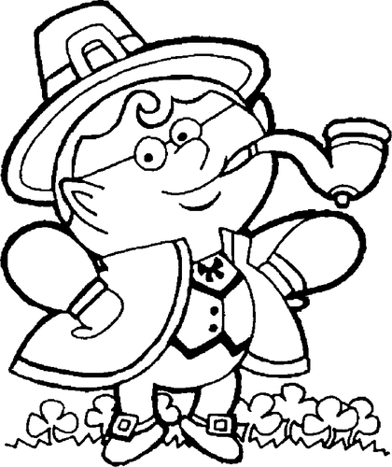  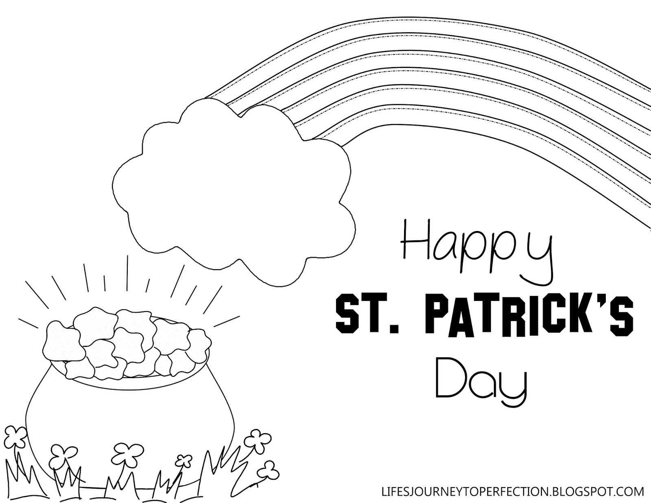  LAURIE CARE CENTER

