FEBRUARY 2020 LAURIE CARE NEWS & VIEWS VOLUME 2 ISSUE 1
Laurie Care Center/Laurie Knolls  P O Box 1068  Laurie MO 65038
573.374.8263  573.374.0603 (Fax)  www.gsnhd.com
DISTRICT ADMINISTRATOR
Lance Smith Happy Valentine’s Day!!
lsmith@gsnhd1.com
ADMINISTRATOR
Katherine Carlson
kcarlson@gsnhd1.com
Happy Leap Year! We gain a day this month! Special days for those born on the 29th of February! We are going to be having a lot of fun this month .We will be watching the K.C. Chief’s win the Super Bowl on the 2nd! Snacks and good times! Then Getting ready for Valentine’s day by making crafts and baking! We are going to have a bake sale on Wednesday the 12th. We always have room for any donated goodies you bake up! Come by and get your sweetheart some yummy treats! We will also be having some live entertainment on the 13th for our Valentine’s Party. Don Joy will be entertaining us!
Brenda Thornton
Activity Director

DIRECTOR OF NURSING
Montana Rios
mrios@gsnhd1.com

MARKETING/ADMISSIONS
Director, Jennie Fisher jfisher@gsnhd1.com

DISTRICT C.F.O.
Lana Merriott
lmerriott@gsnhd1.com
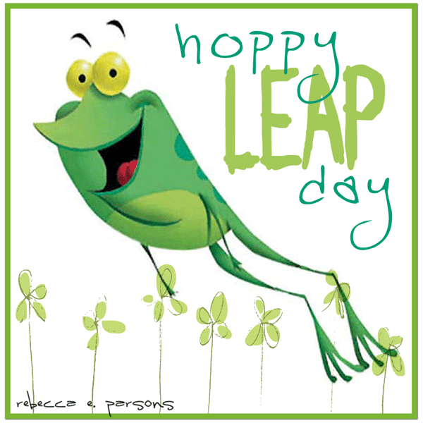
This Photo by Unknown Author is licensed under CC BY-NC-ND
ACTIVITY DIRECTOR
Brenda Thornton
bthornton@gsnhd1.com
This Photo by Unknown Author is licensed under CC BY-NC-ND
DIETARY MANAGER
Jim Neff
jneff@gsnhd1.com
VOLUNTEER ORIENTATION
HUMAN RESOURCES MGR.
Theresa Moyer
tmoyer@gsnhd1.com
Orientation will be held on February 18, 2020
VOLUNTEER COORDINATOR
Saundra Chorpening @ 10 am. Please R.S.V.P. so we will have enough packets for all.
573.207.8806 If you know anyone who is interested in volunteering at the Laurie
Schorpening@gmail.com Care Center/knolls, please call Saundra and let her know. She can be
reached at 573-207-8806. In order to have enough packets it is
necessary to make reservations for this. Thank You!

SUNDAY CHURCH SERVICES-2:00 PM TUESDAY CHURCH

4th Mass @ 10:00 am
2nd The Door 11th Rosary/Mass @ 9:30 am
9th West Lake Christian Church 18th Mass @ 10:00 am
16th Sunrise Bible 25th Mass @ 10:00 am
23rd Kent Memorial

We appreciate those coming on Sundays and St. Patrick Catholic Church on Tuesday’s. Your efforts in providing religious services are a blessing to our residents. Thank you.

BINGO SCHEDULE
Those helping on Tuesdays at 2:00 pm Bonnie Ferment – Wednesday @ 10:00
4th Ozark Chapel UMC Marsha Lenne – Saturday @ 10:00
11th American Legion
18th LCC
25th 1st Baptist Church-Sunrise Beach

This Photo by Unknown Author is licensed under CC BY-SA-NC

FEBRUARY 1 HAZEL CHAPMAN
FEBRUARY 2 DELORES SCHICK
FEBRUARY 14 VIOLA BROWNFIELD
FEBRUARY 24 ANN CHURCH
FEBRUARY 27 WANDA DALLAS
FEBRUARY 28 BETTY THOMPSON

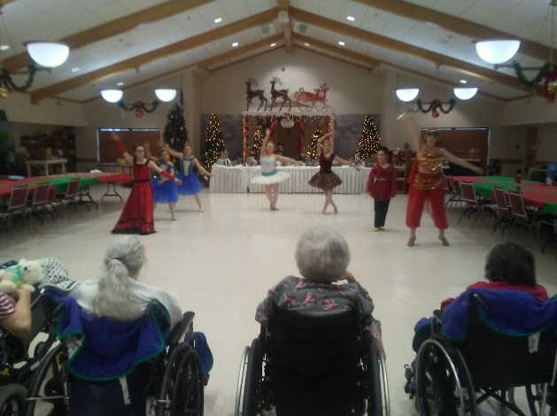
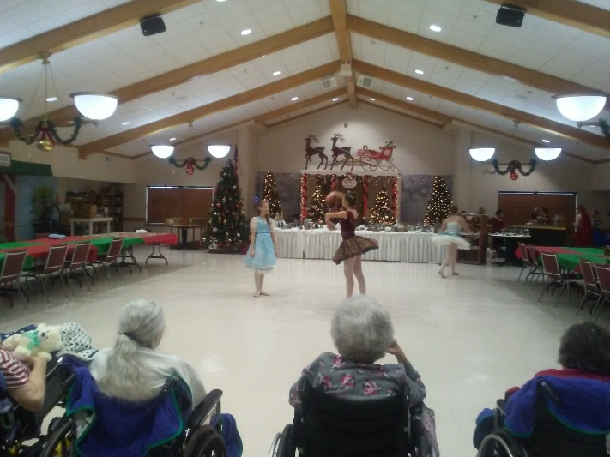

LOZ DANCE TROUP WOWED US WITH A PERFORMANCE FROM “THE NUT CRACKER” THEY DID A FANTASTIC JOB! THE RESIDENTS REALLY ENJOYED THE DANCING AND THE COSTUMES. WE CAN’T WAIT FOR THEM TO COME AGAIN!
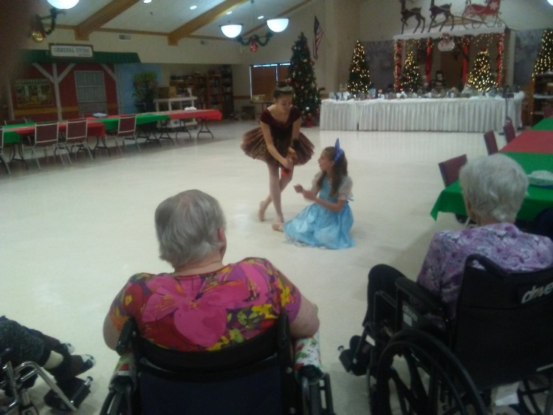
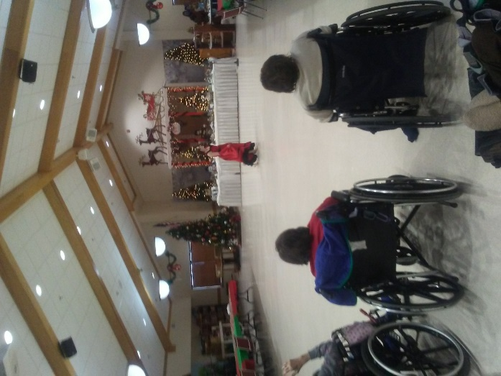
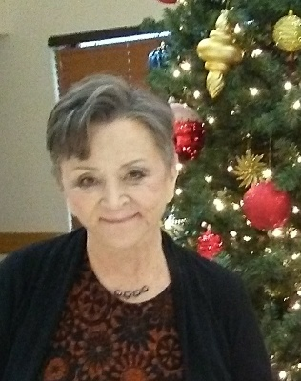
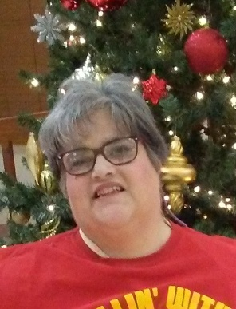
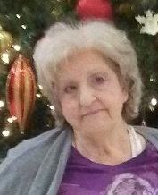
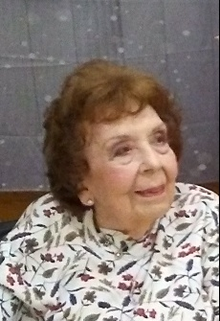
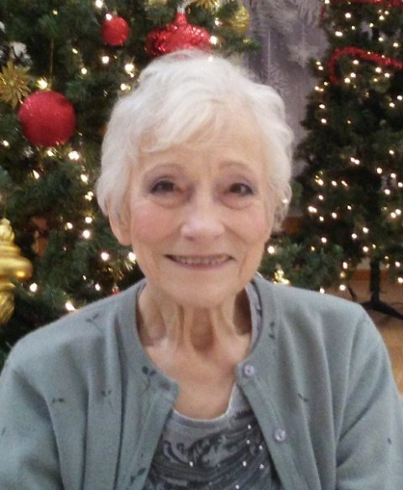
THESE BEAUTIFUL LADIES TOOK ADVANTAGE OF A MAKE OVER FOR NEW YEARS EVE! THEY WERE SOOO GORGEOUS!
This Photo by Unknown Author is licensed under CC BY-NC-ND

