January 2020 LAURIE CARE NEWS & VIEWS VOLUME 1 ISSUE 1
Laurie Care Center/Laurie Knolls  P O Box 1068  Laurie MO 65038
573.374.8263  573.374.0603 (Fax)  www.gsnhd.com
DISTRICT ADMINISTRATOR
Lance Smith HAPPY NEW YEAR!!!
lsmith@gsnhd1.com
ADMINISTRATOR
Katherine Carlson
kcarlson@gsnhd1.com
HAPPY NEW YEAR! We made it through December! Lots of fun was had over the holidays! January will be a lot of fun also! We will be taking down Christmas decorations and getting set up for winter decorations. Other than that, just a month of exercise, crafts, bowling, bingo and other fun things.
A big thank you to all of the staff & volunteers who help us each day! Thank you!!! 😊 Have a great month everyone! Thanks again for all you do!
Brenda Thornton
Activity Director

DIRECTOR OF NURSING
Montana Rios
mrios@gsnhd1.com

MARKETING/ADMISSIONS
Director, Jennie Fisher jfisher@gsnhd1.com

DISTRICT C.F.O.
Lana Merriott
lmerriott@gsnhd1.com

ACTIVITY DIRECTOR
Brenda Thornton
bthornton@gsnhd1.com DIETARY MANAGER
This Photo by Unknown Author is licensed under CC BY-NC-ND
Jim Neff
jneff@gsnhd1.com
VOLUNTEER ORIENTATION
HUMAN RESOURCES MGR.
Theresa Moyer
tmoyer@gsnhd1.com
Orientation will be held on January 14, 2020
VOLUNTEER COORDINATOR
Saundra Chorpening @ 10 am. Please R.S.V.P. so we will have enough packets for all.
573.207.8806 If you know anyone who is interested in volunteering at the Laurie
Schorpening@gmail.com Care Center/knolls, please call Saundra and let her know. She can be
reached at 573-207-8806. In order to have enough packets it is
necessary to make reservations for this. Thank You!

SUNDAY CHURCH SERVICES-2:00 PM TUESDAY CHURCH

7th Mass @ 10:00 am
5th Crossroads Assembly of God 14th Rosary/Mass @ 9:30 am
12th First Baptist Sunrise 21st Mass @ 10:00 am
19th Community Chapel Church of 28th Mass @ 10:00 am
God
26th Ozark Chapel U.M.C.

We appreciate those coming on Sundays and St. Patrick Catholic Church on Tuesday’s. Your efforts in providing religious services are a blessing to our residents. Thank you.

BINGO SCHEDULE
Those helping on Tuesdays at 2:00 pm Bonnie Ferment – Wednesday @ 10:00
7th 1st Baptist Sunrise Beach Marsha Lenne – Saturday @ 10:00
14th LCC
21st Westlake Christian
28th Kent Memorial

BIRTHDAYS

JANUARY 1 HAROLD CARLILE
JANUARY 7 JEROME GALILEY
JANUARY 10 DORIS CHARMICHAEL
JANUARY 15 SHARON ARMSTRONG
JANUARY 22 JIMMY PARKER
JANUARY 27 HELEN CALDWELL
JANUARY 30 CHARLOTTE POWELL
This Photo by Unknown Author is licensed under CC BY-NC
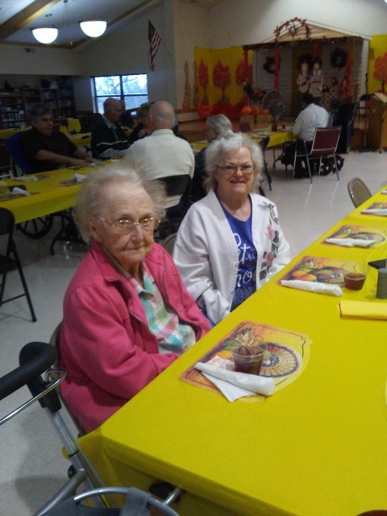
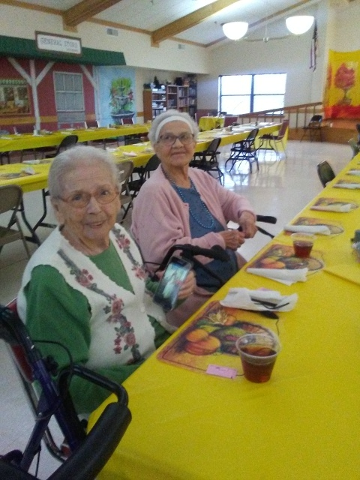
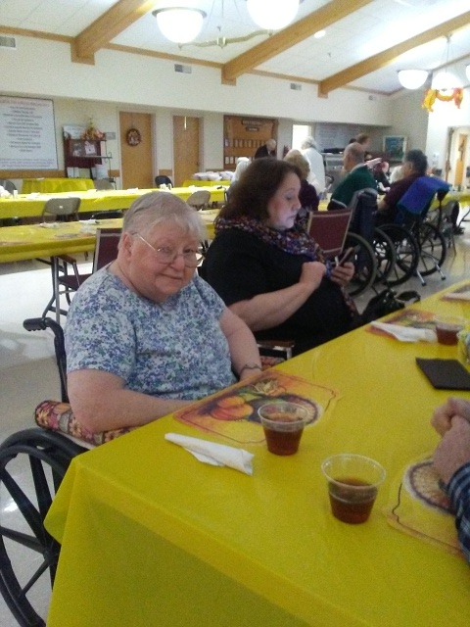

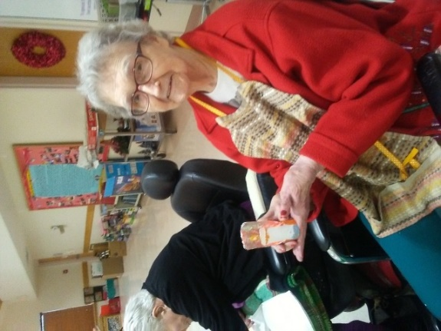
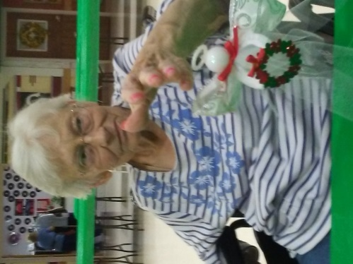
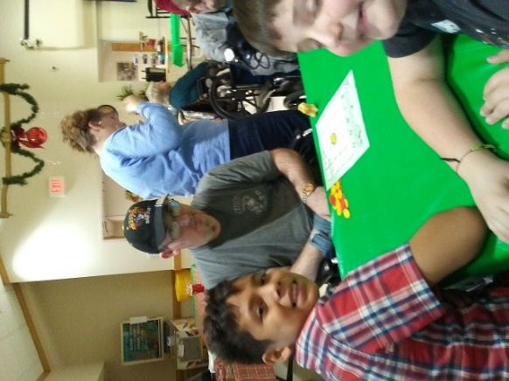
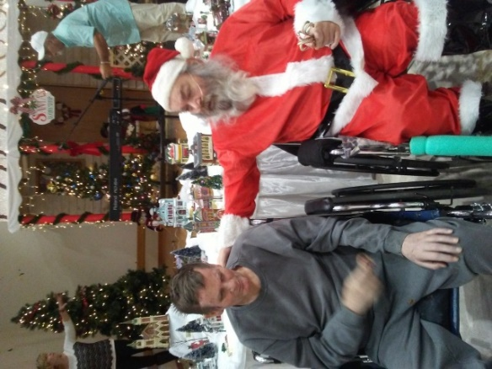
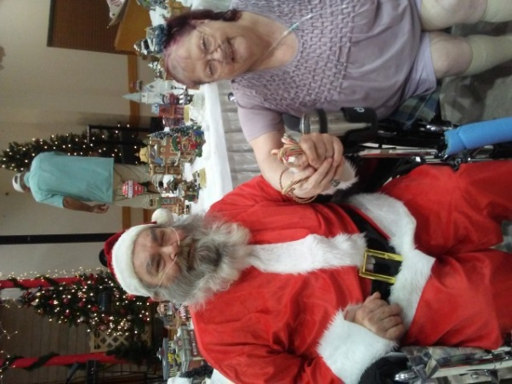
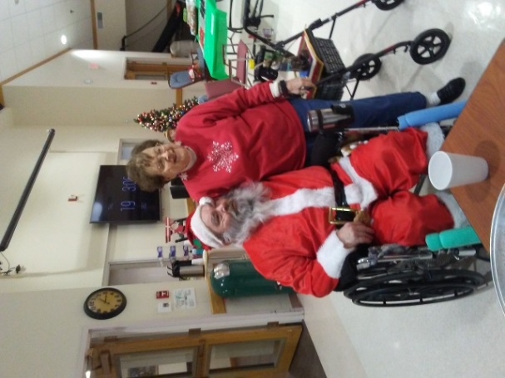

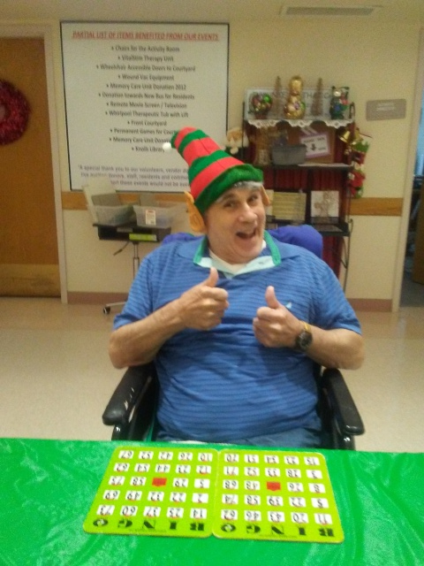
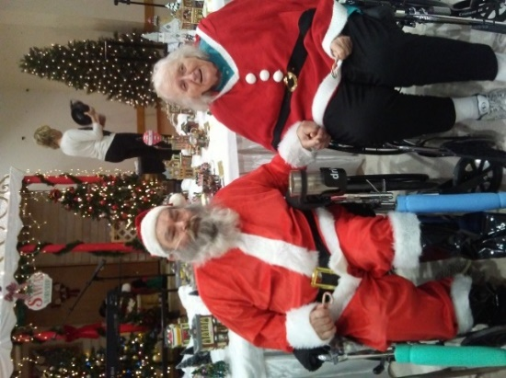
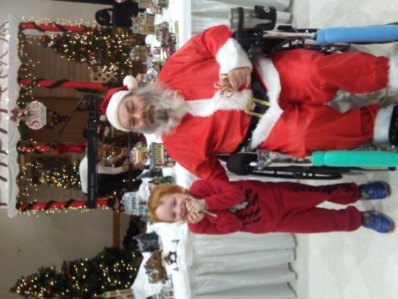

By Esther Mary Walker

Blessed are they who understand
My faltering step and shaking hand.

Blessed, who know my ears today
Must strain to hear the things they say.

Blessed are those who seem to know
My eyes are dim and my mind is slow.

Blessed are they who looked away
When I spilled my tea that weary day.

Blessed are they, with cheery smile,
Stopped to chat for a little while.

Blessed are they who know the way
To bring back memories of yesterday.

Blessed are those who never say
“you’ve told me that story twice today”.

Blessed are they who made it known
That I am loved, respected and not alone.

Blessed are they who will ease the days
Of my journey home, in loving ways.

