**December, 2019 LAURIE CARE NEWS & VIEWS VOLUME 9 ISSUE 11**

**Laurie Care Center/Laurie Knolls  P O Box 1068  Laurie MO 65038**

**573.374.8263  573.374.0603 (Fax)  www.gsnhd.com**

**DISTRICT ADMINISTRATOR**

**Lance Smith** ACTIVITY CORNER

[**lsmith@gsnhd1.com**](mailto:lsmith@gsnhd1.com)

**WOW, December is upon us once again! Get our busy hats on! ☺**

**We will begin decorating for Christmas on Dec. 2 this year. We will have the whole first week of Dec. to get it all decked out. If you would like to come help, that would be sooo appreciated.**



We will set up for the Christmas Shopping Mall on December 9. The mall will be open on Dec. 10 from 9am-11am and 1pm-3pm. We will be wrapping gifts for them, if any one would like to help cashier and wrap gifts, please join us. If anyone would like to donate items for the shopping mall, bring them to the activity office prior to Dec. 9. Thanks

We will be having a Christmas Party for residents and their families, with live entertainment on December 12. If anyone would like to help serve refreshments to the guests and enjoy the party, that would be awesome

**Join us for the lighting of the Christmas Village of Memories on December 13, at 2pm.**

**Christmas party for residents and children will be held on December 19 @ 2 pm**

**A big thank you to all of the staff & volunteers who help us each day! Thanks again for all you do!**

**Brenda Thornton**

**ADMINISTRATOR**

**Katherine Carlson**

**kcarlson**[**@gsnhd1.com**](mailto:mspires@gsnhd1.com)

**DIRECTOR OF NURSING**

**Montana Rios**

[**mrios@gsnhd1.com**](mailto:mrios@gsnhd1.com)

**MARKETING/ADMISSIONS**

**Director, Jennie Fisher** [**jfisher@gsnhd1.com**](mailto:jfisher@gsnhd1.com)

**DISTRICT C.F.O.**

**Lana Merriott** [**lmerriott@gsnhd1.com**](mailto:lmerriott@gsnhd1.com)

**ACTIVITY DIRECTOR Brenda Thornton**

[**bthornton@gsnhd1.com**](mailto:bthornton@gsnhd1.com) **DIETARY MANAGER**

**Jim Neff**

[**jneff@gsnhd1.com**](mailto:jneff@gsnhd1.com)

**SOCIAL SERVICES DIRECTOR**

**Diana Wilson**

[**dwilson@gsnhd1.com**](mailto:dwilson@gsnhd1.com)

Reminders

If a resident will be leaving the facility for the holidays, a heads up to the nurses who care for them three days in advance is appreciated. This gives them time to plan for anything they might need to make ready for them to be gone.

**MAINTENANCE SUPERVISER**

**Clint Hatcher**

[**chatcher@gsnhd1.com**](mailto:chatcher@gsnhd1.com)

**HUMAN RESOURCES MGR.**

**Theresa Moyer**

[**tmoyer@gsnhd1.com**](mailto:tmoyer@gsnhd1.com)

**VOLUNTEER COORDINATOR**

**Saundra Chorpening**

**573.207.8808**

[**sl.chorpening@gmail.com**](mailto:sl.chorpening@gmail.com)

**Mo Do TITLE VI PROGRAM – What a privilege to be a part of this program for purchasing.**

***SUNDAY CHURCH SERVICES-2:00 PM TUESDAY CHURCH SERVICES***

**1st First Baptist 3rd Mass @ 10:00 am**

**8th Ozark Chapel 17th Rosary/Mass @ 9:30am**

**15th “Open Door 24th Mass @ 10:00**

**22nd Sunrise Bible 31stMass @ 10:00 am**

**29th Westlake Christian Church**

**We appreciate those coming on Sundays and St. Patrick Catholic Church on Tuesday’s. Your efforts in providing religious services are a blessing to our residents. Thank you.**

***BINGO SCHEDULE***

**Those helping on Tuesdays at 2:00 pm Bonnie Ferment – Wednesday @ 10:00**

**3th Ozark Chapel UMC Marsha Lenne – Saturday @ 10:00**

**10th LCC**

**17th West Lake Christian**

**26th Christmas week**

***BIRTHDAY SCHEDULE***



**6th Rosalee Davis 16th Maria Lopez**

**8th Stephen Sorensen 19th Shirley Hunter**

**10th Jimmie Webb 24th Jeffery Robbinson**

**11th David Hummel**

**12th Pauline Schooler**

**12th Ramona Condra**

**The Laurie Care Center will be supplying the resident’s birthday gifts this month. Thank you!**

***VOLUNTEER ORIENTATION***

**This will be held on 12/17/19 @ 10am. Please R.S.V.P so we will have enough packets for everyone. If you know someone who would is interested in volunteering at Laurie Care Center/Knolls, please call Saundra and let her know. She can be reached at 573.207.8806. In order to have enough packets available it is necessary to make reservations for this. Thank you!**

**Great Memories**

**Balloon toss is so fun when Chris shows up!**

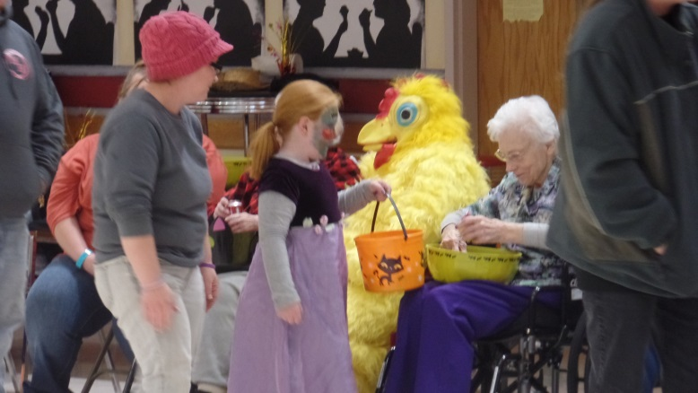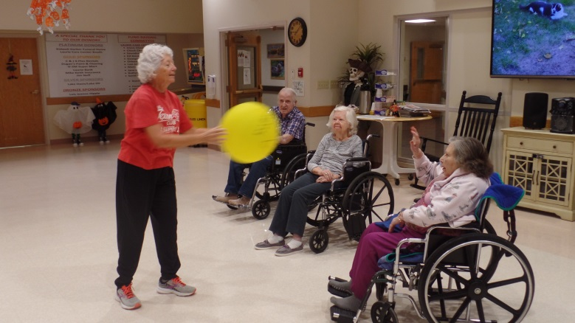

**GREAT TIMES**

**GREAT MEMORIES MADE**

**Salute to our Veterans**

