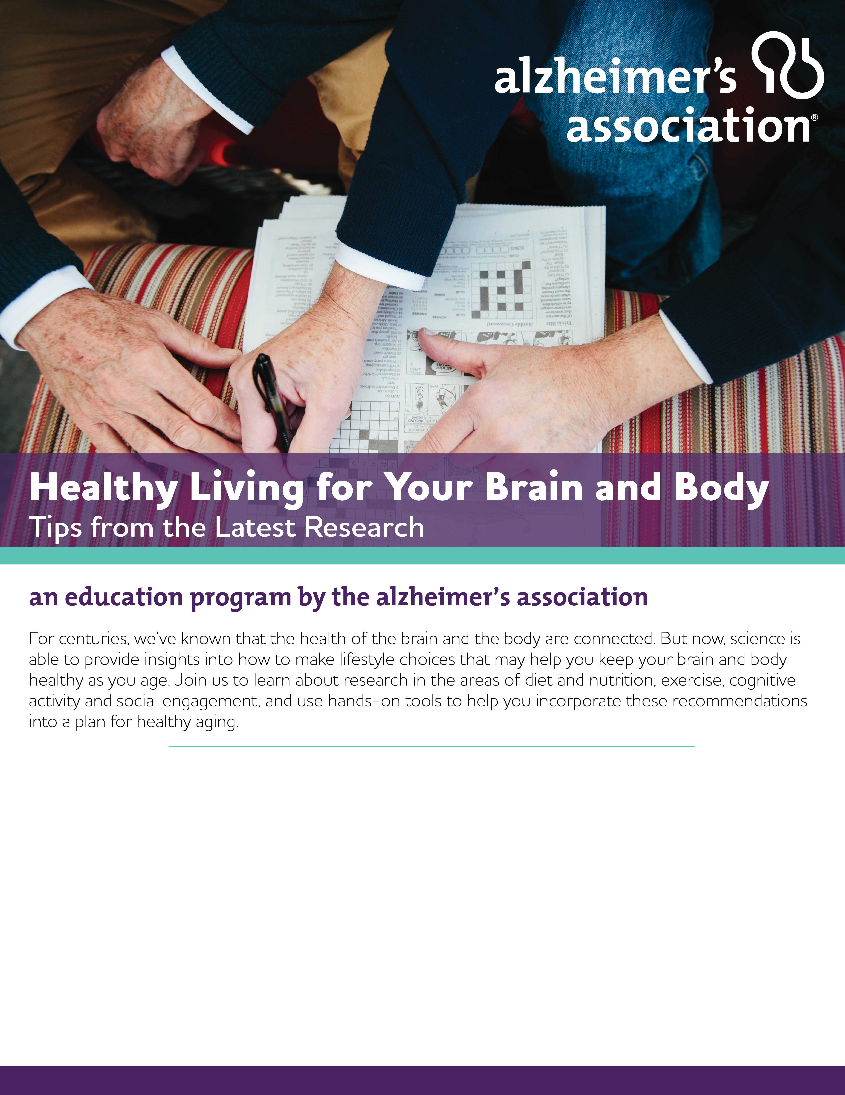

Wednesday, June 19, 2019 | 10:00 A.M. – 11:00 A.M
Laurie Care Center
610 HWY0. | Laurie, MO

.

REGISTRATION INFO HERE.

